# ZOOM BEST PRACTICES FOR ATTENDEES

# WAITING ROOM

Once you log into Zoom, you will be placed in a waiting room until the meeting is ready to begin.

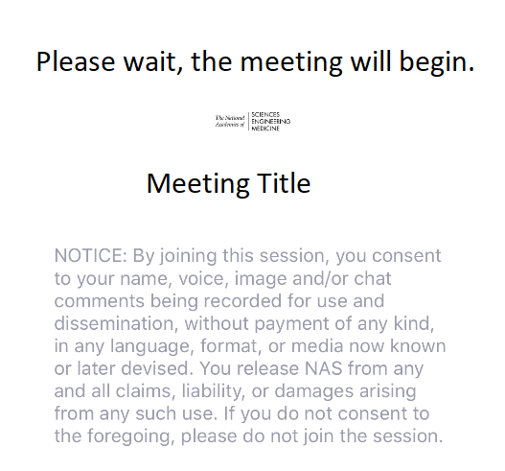

# GENERAL AUDIO & WEBCAM GUIDANCE

**We ask that all participants keep themselves MUTED with VIDEO STOPPED until asked otherwise.**

In Main Navigation (bottom console), participants are able to control their audio and webcam by clicking on the icons: AUDIO: Mute/Unmute by clicking on the icon on the bottom left of your Zoom control panel   
WEBCAM: Start/Stop video (during Q&A) by clicking on the icon on the bottom left of your Zoom control panel

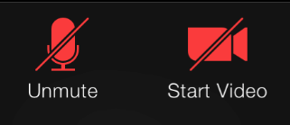 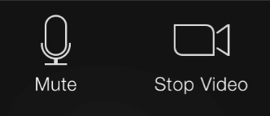

# “RAISING HAND” DURING Q&A

In the Zoom control panel, click on “Participants” then click on “Raise Hand” in the bottom left corner of the Participants window to get the moderator’s attention during Q&A.

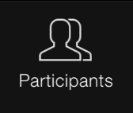 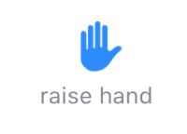

# NEED HELP?

In the Zoom control panel, click on “Chat” then send a message to TRB staff with your request.

